**DFD OF ONLINE JOB PORTAL**

**Level 0 DFD of online job portal**

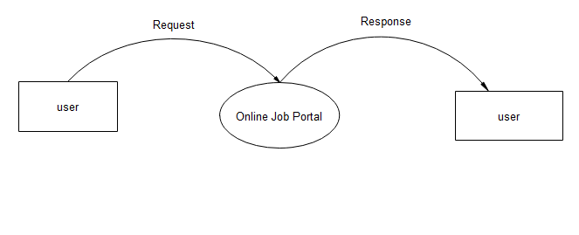

**Level 1 DFD of Admin**

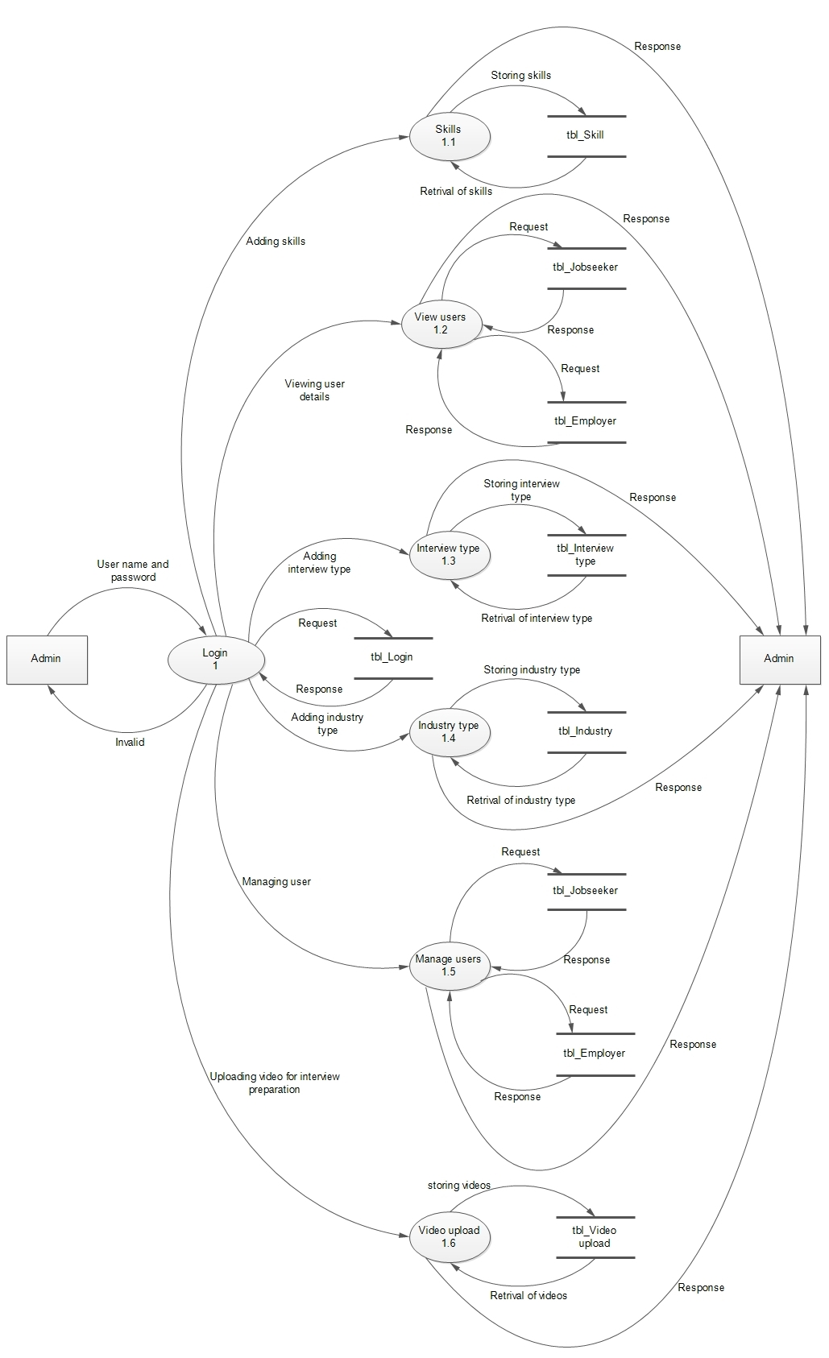

**Level 1 DFD of Employer**

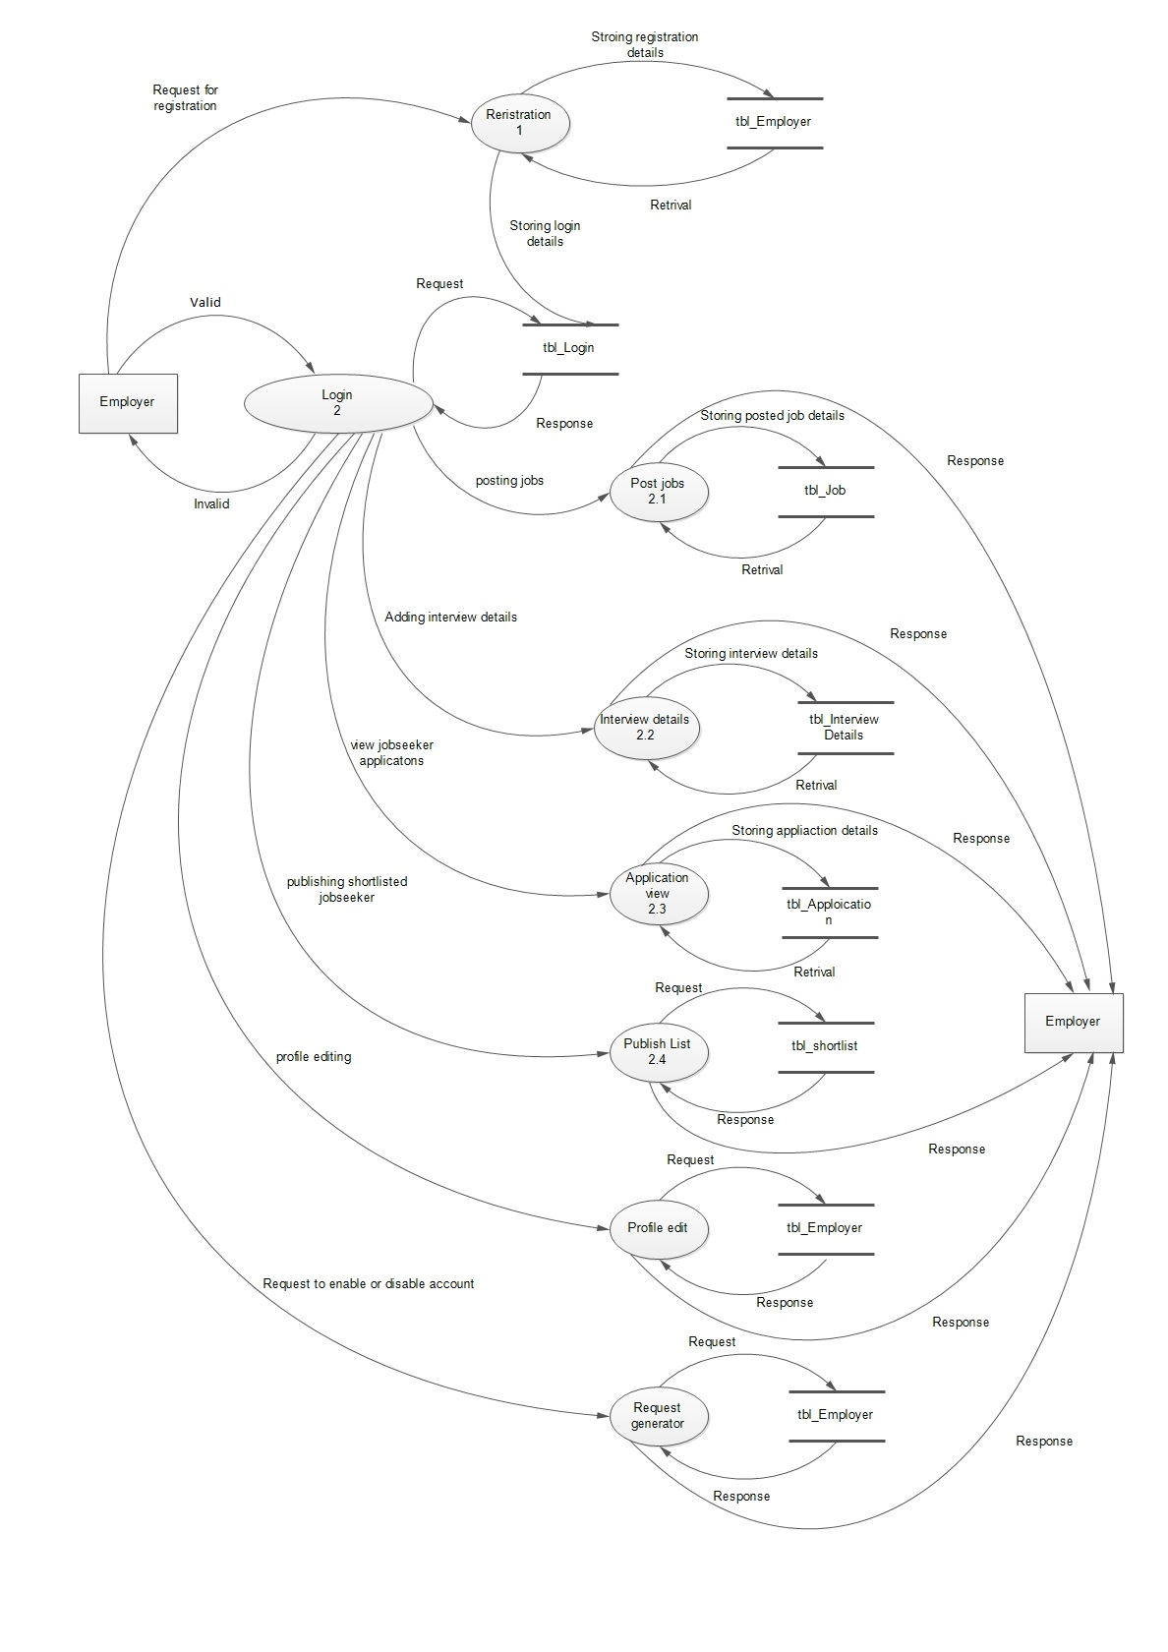

**Level 1 DFD of Jobseeker**

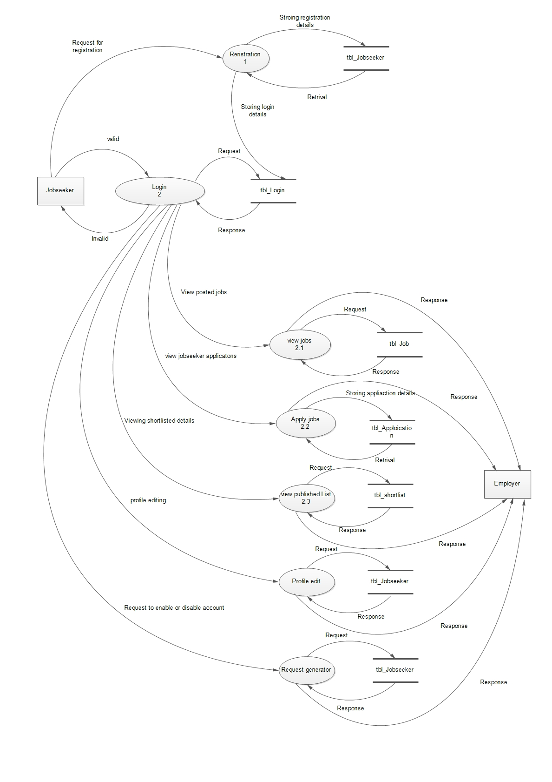

**Level 2 DFD of Admin for view users**

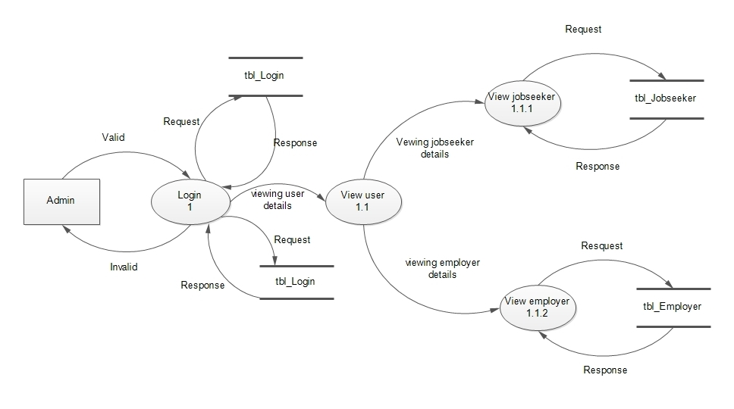

**Level 2 DFD of Admin for Manage users**

